**TRƯỜNG CAO ĐẲNG CÔNG NGHỆ THỦ ĐỨC**

**KHOA CÔNG NGHỆ THÔNG TIN**

**🙟🕮🙝**



**BÁO CÁO ĐỒ ÁN MÔN HỌC**

**Môn:** Nhập môn Công Nghệ Phần Mềm

**GV:** Thầy Phan Gia Phước

**Nội dung:** MinCoffee_SRS_TuTaiMinhSang_Ver1.6

**Thành viên nhóm:**

Châu Nhật Tài

Nguyễn Đức Sáng

Phạm Thế Minh

Võ Tú

✰✰✰✰✰

*Tp. Hồ Chí Minh, tháng 12/2023*

**Mục lục**

1. Introduction 1

1.1. Purpose 1

1.2. Project proposal 1

2. UI 1

2.1. Users/Customers 1

2.1.1. Sign Up (Phạm Thế Minh) 1

2.1.2. Login 5

2.1.3. Main Page 6

2.1.4. Order Detail 8

2.1.5. Cart Page (Võ Tú) 10

2.1.6. Account Page 14

2.1.7. Notify Page 16

2.1.8. Store Page 17

2.2. Admin/Managers 19

2.2.1. Admin Main Page – Management Products (Châu Nhật Tài) 19

2.2.2. Import Store – Management Store (Nguyễn Đức Sáng) 29

3. Non-Functional Requirements 32

3.1. Enviroment 32

3.2. Capacity 32

3.3. Multitasking 33

3.4. Performance 33

3.5. Safe 33

3.6. Security 33

3.7. Low battery consumption 33

3.8. Software installs on all types of devices 34

3.9. Stable level of software performance 34

3.10. Availability requirements: 34

3.11. Quality characteristics of the software: 34

3.12. Restaurant location nearby 34

3.13. Automatically congratulate user on their birthday 34

3.14. Automatically suggest dishes 34

3.15. Ability to develop additional functions: 34

3.16. System data security 34

3.17. Default binding in functions 34

3.18. Performance and Scalability 34

3.19. User Interface 35

3.20. Reliability and Availability 35

3.21. Organizational requirements 35

3.22. External requirements 35

3.22.1. User feedback mechanism: 35

3.22.2. Legal requirements: 35

4. Use-Case diagram 35

4.1. Actors 36

4.2. Use-Cases 36

4.3. Use-Case Manage Products 37

4.3.1. Use-Case ID: 02 37

4.3.2. Use-Case Owner Name: Châu Nhật Tài 37

4.3.3. Brief Description 37

4.3.4. Flow of Events 37

4.3.5. Special Requirements 37

4.3.6. Pre-Conditions 38

4.3.7. Post-Conditions 38

4.3.8. Extension Points 38

4.4. Use-Case Sign Up 38

4.4.1. Use-Case ID: 01 38

4.4.2. Use-Case Owner Name: Phạm Thế Minh 38

4.4.3. Brief Description 38

4.4.4. Flow of Events 38

4.4.5. Special Requirements 39

4.4.6. Pre-Conditions 39

4.4.7. Post-Conditions 39

4.4.8. Extension Points 39

4.5. Use-Case Manage Stores 39

4.5.1. Use-Case ID: 04 39

4.5.2. Use-Case Owner Name: Nguyễn Đức Sáng 39

4.5.3. Brief Description 39

4.5.4. Flow of Events 39

4.5.5. Special Requirements 41

4.5.6. Pre-Conditions 41

4.5.7. Post-Conditions 41

4.5.8. Extension Points 41

4.6. Use-Case Cart 41

4.6.1. Use-Case ID: 03 41

4.6.2. Use-Case Owner Name: Võ Tú 41

4.6.3. Brief Description 41

4.6.4. Flow of Events 41

4.6.5. Special Requirements 42

4.6.6. Pre-Condition 42

4.6.7. Post-Conditions 42

4.6.8. Extension Points 42

5. Q & A List 42

5.1. 4.1 Page 4/70 REQUIREMENT? 43

5.2. 4.1 Page 5/70 REQUIREMENT ENGINEERING? 43

5.3. 4.2 Page 9/70 USER REQUIREMENT? 43

5.4. 4.2 Page 10/70 SYSTEM REQUIREMENT? 43

5.5. 4.2 Page 12/70 FUNCTIONAL REQUIREMENT? 43

5.6. 4.2 Page 12/70 NON-FUNCTIONAL REQUIREMENT? 44

5.7. 4.3 Page 14/70 FUNCTIONAL REQUIREMENT? 44

5.8. 4.3 Page 15/70 MENTCARE SYSTEM? 44

5.9. 4.3 Page 16/70 REQUIREMENT IMPRECISION? 44

5.10. 4.4 Page 19/70 NON-FUNCTIONAL REQUIREMENT 44

5.11. 4.4 Page 21/70 NON-FUNCTIONAL CLASSSIFICATION 45

5.12. 4.4 Page 22/70 NON-FUNCTIONAL REQUIREMENT IMPLEMENTDATION? 45

5.13. 4.5 Page 28/70 REQUIREMENT ENGINEERING PROCESS? 45

5.14. 4.5 Page 30/70 REQUIREMENT ELICITATION AND ANALYSIS? 45

5.15. 4.5 Page 31/70 REQUIREMENT ELICITATION? 46

5.16. 4.5 Page 32/70 PROBLEM OF REQUIREMENT ELICITATION? 46

5.17. 4.5 Page 35/70 REQUIREMENT DISCOVERY? 46

5.18. 4.5 Page 36/70 SYSTEM STAKEHOLDERS? 47

5.19. 4.6 Page 41/70 INTERVIEWING? 47

5.20. 4.6 Page 42/70 INTERVIEW IN PRACTICE? 47

RECORD OF CHANGE

*A – Added, M – Modified, D - Deleted

|  |  |  |  |  |
| --- | --- | --- | --- | --- |
| **Effective Date** | **Changed Items** | **A*, M, D** | **Change Description** | **New Verision** |
| 09-28-2023 | First Release | A* |  | ver 1.0 |
| 10-05-2023 | Second Release | M | - Added Layout views: Login, Signup, Order, Choose Option  - Added Screen Description  - Added Workflow Table | ver 1.1 |
| 10-12-2023 | Third Release | M | - Added 4 news Feature:  + The Minh: Order At Table, Order Take Away (both way can choose time)  + Nhat Tai: Click icon Document to access Report Monthly Revenue  + Duc Sang: Added 3 CRUDS (Add/Delete/Update) menu items  + Vo Tu: Added Vouchers function | ver 1.2 |
| 02-11-2023 | Fourth Release | M | + Nhat Tai Added Notify feature  + The Minh Added Store Location Feature  + Duc Sang Added CRUD – Import Strorage Feature  + Vo Tu Added Payment Feature | ver 1.3 |
| 23-11-2023 | Fifth Release | M | - Added Non-Functional Requirements  + Each members contribute 3 Non-Functional Requirements  + Except Vo Tu contribute 2 Non-Functional Requirements | ver 1.4 |
| 30-11-2023 | Sixth Release | M | - Added Use-Case Diagrams | ver 1.5 |
| 07-12-2023 | Seventth Release | M | - Added Activity in Workflow at UI | ver 1.6 |

EVALUATE GROUP MEMBERS:

|  |  |  |  |  |  |  |
| --- | --- | --- | --- | --- | --- | --- |
| **Numerical Order** | **ID Students** | **Full Name** | **Time** | **Work** | **Point** | **Version** |
| 1 | 22211TT0103 | Châu Nhật Tài (leader) | 07-12-2023 | -Added Activities (Management Products): Add Acti, Edit Acti, Delete Acti, Report Acti, Logout Acti | 10 | 1.6 |
| 2 | 22211TT0690 | Nguyễn Đức Sáng | -Added Activities (Management Stores): Add Acti, Edit Acti, Delete Acti, Report Acti, Logout Acti | 10 |
| 3 | 22211TT0085 | Phạm Thế Minh | -Added Activities (Sign Up) | 10 |
| 4 | 22211TT0063 | Võ Tú | -Added Activities (Cart) | 10 |

# Introduction

## Purpose

The purpose of this document is to present a detailed description of the MinCoffee program. It will explain the purpose and features of the system, the interfaces of the system, what the system will do, the constraints under which it must operate and how the system will react to external stimuli.

## Project proposal

With the Vietnamese people's need to use and enjoy coffee every day, shops serving coffee & drinks are increasing day by day. Among them is a large coffee chain with the brand HighLands. Up to the coffee chain, there will be a very large data system that needs to be stored. To solve that problem, our group chose the topic of managing the MinCoffee chain. Desire to meet customer service needs as well as data management for the MinCoffee coffee shop chain.

# UI

## Users/Customers

### Sign Up (Phạm Thế Minh)

Continue Button

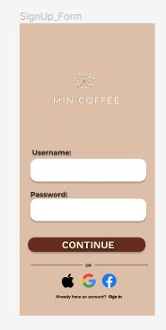

Password TextView

Username TextView

Facebook Icon

Google Icon

Apple Icon

#### Screen Description

|  |  |  |  |  |  |  |
| --- | --- | --- | --- | --- | --- | --- |
| **No** | **Field Name** | **Control Type** | **Required** | **Data Type** | **Default Value** | **Description** |
| **1** | Username | Text View | No | String | Blank | Text Box Username, let user input data |
| **2** | Password | Text View | No | String | Blank | Text Box Password, let user input data |
| **3** | Continue | Button | No | Button | Text | Continue Button, click to go Login Screen |
| **4** | Apple | Button | No | Button | Image | Click to Sign Up with Apple Account |
| **5** | Google | Button | No | Button | Image | Click to Sign Up with Google Account |
| **6** | Facebook | Button | No | Button | Image | Click to Sign Up with Facebook Account |

#### WorkFlow

##### Table Workflow

|  |  |  |
| --- | --- | --- |
| **Scenario** | **Actor** | **System** |
| **1. User click to Continue Button** | 1.1 User click to Continue Button | 1.2 Check Username & Password |
| 1.3 If Username & Password don’t have in Database, Show Message: “Sign Up Successful!” |
| 1.4 Move to Login Screen |
| **2. User click to Apple Icon** | 2.1 User click to Apple Icon | 2.1 Check Username & Password |
| 2.2 If Username & Password correct, Show Message: “Sign Up Successful!” |
| 2.3 Move to Login Screen |
| **3. User click to Google Icon** | 3.1 User click to Google Icon | 3.1 Check Username & Password |
| 3.2 If Username & Password correct, Show Message: “Sign Up Successful!” |
| 3.3 Move to Login Screen |
| **4. User click to Google Icon** | 4.1 User click to Google Icon | 4.1 Check Username & Password |
| 4.2 If Username & Password correct, Show Message: “Sign Up Successful!” |
| 4.3 Move to Login Screen |

##### Activity

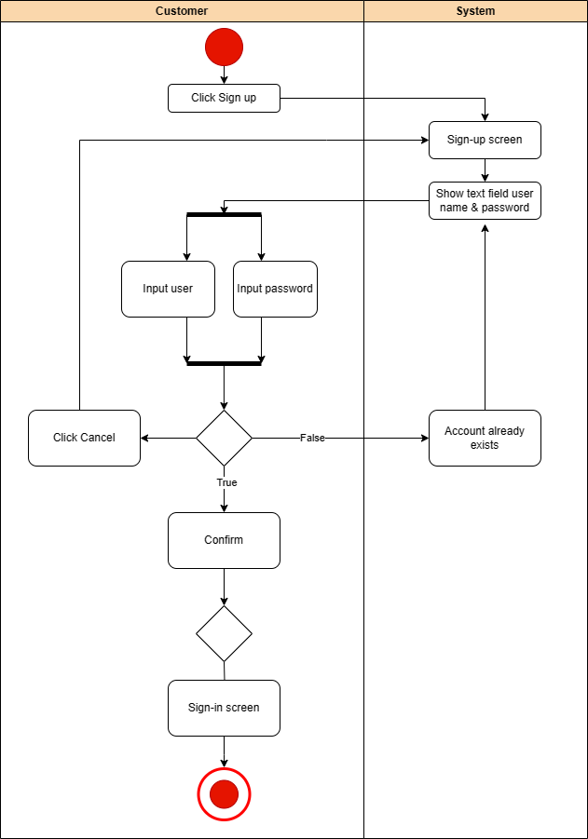

### Login

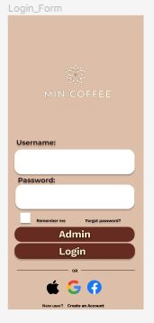

Login Button

Admin Button

#### Screen Description

|  |  |  |  |  |  |  |
| --- | --- | --- | --- | --- | --- | --- |
| **No** | **Field Name** | **Control Type** | **Required** | **Data Type** | **Default Value** | **Description** |
| **1** | Username | Text View | No | String | Blank | Text Box Username, let user input data |
| **2** | Password | Text View | No | String | Blank | Text Box Password, let user input data |
| **3** | Continue | Button | No | Button | Text | Continue Button, click to go Login Screen |
| **4** | Apple | Button | No | Button | Image | Click to Sign Up with Apple Account |
| **5** | Google | Button | No | Button | Image | Click to Sign Up with Google Account |
| **6** | Facebook | Button | No | Button | Image | Click to Sign Up with Facebook Account |
| **7** | Admin | Button | No | Button | Text | Click to access Admin Feature |
| **8** | Login | Button | No | Button | Text | Click to access User/Customers Feature |

#### WorkFlow

|  |  |  |
| --- | --- | --- |
| **Scenario** | **Actor** | **System** |
| **1. User click to Login Button** | 1.1 User click to Login Button | 1.2 Check Username & Password |
| 1.3 If Username & correct, Show Message: “Login Successful!” |
| 1.4 Move to Main Page |
| **2. User click to Apple Icon** | 2.1 User click to Apple Icon | 2.1 Check Username & Password |
| 2.2 If Username & Password correct, Show Message: “Login Successful!” |
| 2.3 Move to Home Page |
| **3. User click to Google Icon** | 3.1 User click to Google Icon | 3.1 Check Username & Password |
| 3.2 If Username & Password correct, Show Message: “Login Successful!” |
| 3.3 Move to Main Page |
| **4. User click to Google Icon** | 4.1 User click to Google Icon | 4.1 Check Username & Password |
| 4.2 If Username & Password correct, Show Message: “Login Successful!” |
| 4.3 Move to Home Page |
| **5. User ticked Remember me Checkbox** | 5.1 User Ticked remember me Checkbox | 5.2 System save Username for next time login |
| **6. User click to Forgot Password? linked** | 6.1 User click to Forgot Password linked | 6.2 System move to Sign Up Page |

### Main Page

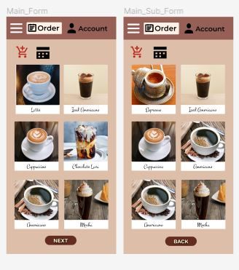

Image

Store

Cart

#### Screen Description

|  |  |  |  |  |  |  |
| --- | --- | --- | --- | --- | --- | --- |
| **No** | **Field Name** | **Control Type** | **Required** | **Data Type** | **Default Value** | **Description** |
| **1** | Order | Button | No | Button | Text | Order Button click to move in Order Page |
| **2** | Account | Button | No | Button | Text | Account Button click to move in Account Page |
| **3** | Cart | Button | No | Button | Icon | Cart Button click to move in Cart Page |
| **4** | Store | Button | No | Button | Icon | Store Button click to move in Store Page |
| **5** | Next | Button | No | Button | Text | Click Next Button to move Next Page |
| **6** | Back | Button | No | Button | Text | Click Back Button to back Previous Page |
| **7** | Image | Image View | Yes | Image | Image | Show Item Image |

#### WorkFlow

|  |  |  |
| --- | --- | --- |
| **Scenario** | **Actor** | **System** |
| **1. User click to Image Item** | 1.1 User click to Image Item | 1.2 Move to Order Detail Page |
| **2. User click to Order Button** | 2.1 User click to Order Button | 2.2 Move to Order Detail Page |
| **3. User click to Account Button** | 3.1 User click to Account Button | 3.2 Move to Account Page |
| **4. User click to Store Button** | 4.1 User click to Store Button | 4.2 Move to Store Page |
| **5. User click to Cart Button** | 5.1 User click to Cart Button | 5.2 Move to Cart Page |
| **6. User click to Next Button** | 6.1 User click to Next Button | 6.2 Move to Next Main Page |
| **7. User click to Back Button** | 7.1 User click to Back Button | 7.2 Back to Previous Main Page |

### Order Detail

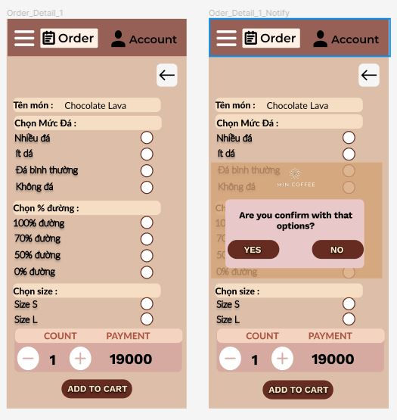

#### Screen Description

|  |  |  |  |  |  |  |
| --- | --- | --- | --- | --- | --- | --- |
| **No** | **Field Name** | **Control Type** | **Required** | **Data Type** | **Default Value** | **Description** |
| **1** | Radio | Radio Button | Yes | Radio Button | Blank | Radio Button to choose option of Items |
| **2** | Plus | Button | Yes | Button | Icon | Plus Button to increase amount of Items |
| **3** | Minus | Button | Yes | Button | Icon | Minus Button to decrease amount of Items |
| **4** | Back | Button | No | Button | Icon | Click Back Button to back Main Page |
| **5** | Add to cart | Button | No | Button | Text | Click Add to cart Button show message, if confirm add item in Cart Page, else return Order Detail Page |

#### WorkFlow

|  |  |  |
| --- | --- | --- |
| **Scenario** | **Actor** | **System** |
| **1. User click to Radio Button** | 1.1 User click to Radio Button | 1.2 Radio Button checked = true |
| **2. User click to Plus Button** | 2.1 User click to Plus Button | 2.2 Show amount of Items increase |
| **3. User click to Minus Button** | 3.1 User click to Minus Button | 3.2 Show amount of Items decrease |
| **4. User click to Add to cart Button** | 4.1 User click to Add to cart Button | 4.2 Show Message |
| 4.3 If confirm, add item to Cart Page |
| 4.4 Else return Order Detail Page |
| **5. User click to Back Button** | 5.1 User click to Back Button | 5.2 Back to Previous Main Page |

### Cart Page (Võ Tú)

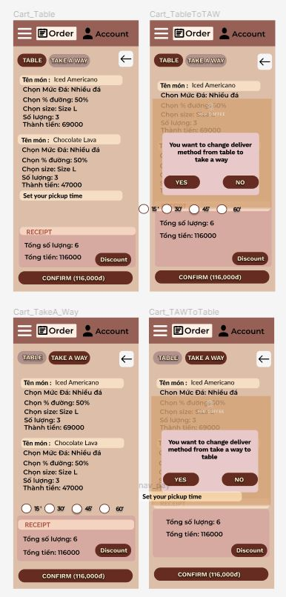

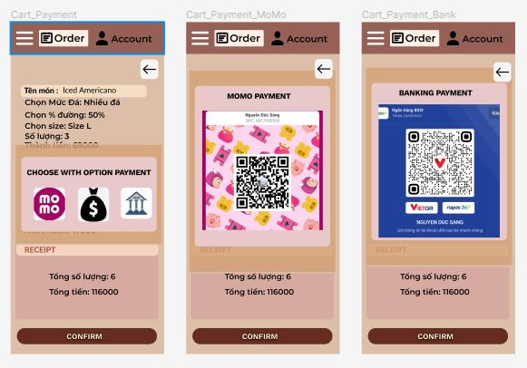

#### Screen Description

|  |  |  |  |  |  |  |
| --- | --- | --- | --- | --- | --- | --- |
| **No** | **Field Name** | **Control Type** | **Required** | **Data Type** | **Default Value** | **Description** |
| **1** | Radio | Radio Button | Yes | Radio Button | Blank | Radio Button to choose option of Items |
| **2** | Table | Button | Yes | Button | Text | Table Button to take Order Item at Store |
| **3** | Take Away | Button | Yes | Button | Text | Take Away Button to get Item take away/drive thru |
| **4** | Discount | Button | No | Button | Text | Click Discount Button to Add code Discount |
| **5** | Confirm | Button | No | Button | Text | Click Confirm Button show Sum Money of All Items, if confirm show three icons Payment, else return Cart Page |
| **6** | Back | Button | No | Button | Icon | Click Back Button to return Main Page |

#### WorkFlow

##### Table Workflow

|  |  |  |
| --- | --- | --- |
| **Scenario** | **Actor** | **System** |
| **1. User click to Radio Button** | 1.1 User click to Radio Button | 1.2 Radio Button checked = true |
| **2. User click to Table Button** | 2.1 User click to Table Button | 2.2 Choose Order Item at Store |
| **3. User click to Take Away Button** | 3.1 User click to Take Away Button | 3.2 Choose Get Item by Take Away |
| **4. User click to Discount Button** | 4.1 User click to Discount Button | 4.2 Show Text View |
| 4.3 User can input Discount code |
| 4.4 Return Cart Page |
| **5. User click to Back Button** | 5.1 User click to Back Button | 5.2 Back to Previous Main Page |
| **6. User click to Confirm Button** | 6.1 User click to Confirm Button | 6.2 Show Message |
| 6.3 If confirm, show three icons Payment |
| 6.4 Else return to Cart Page |

##### Activity

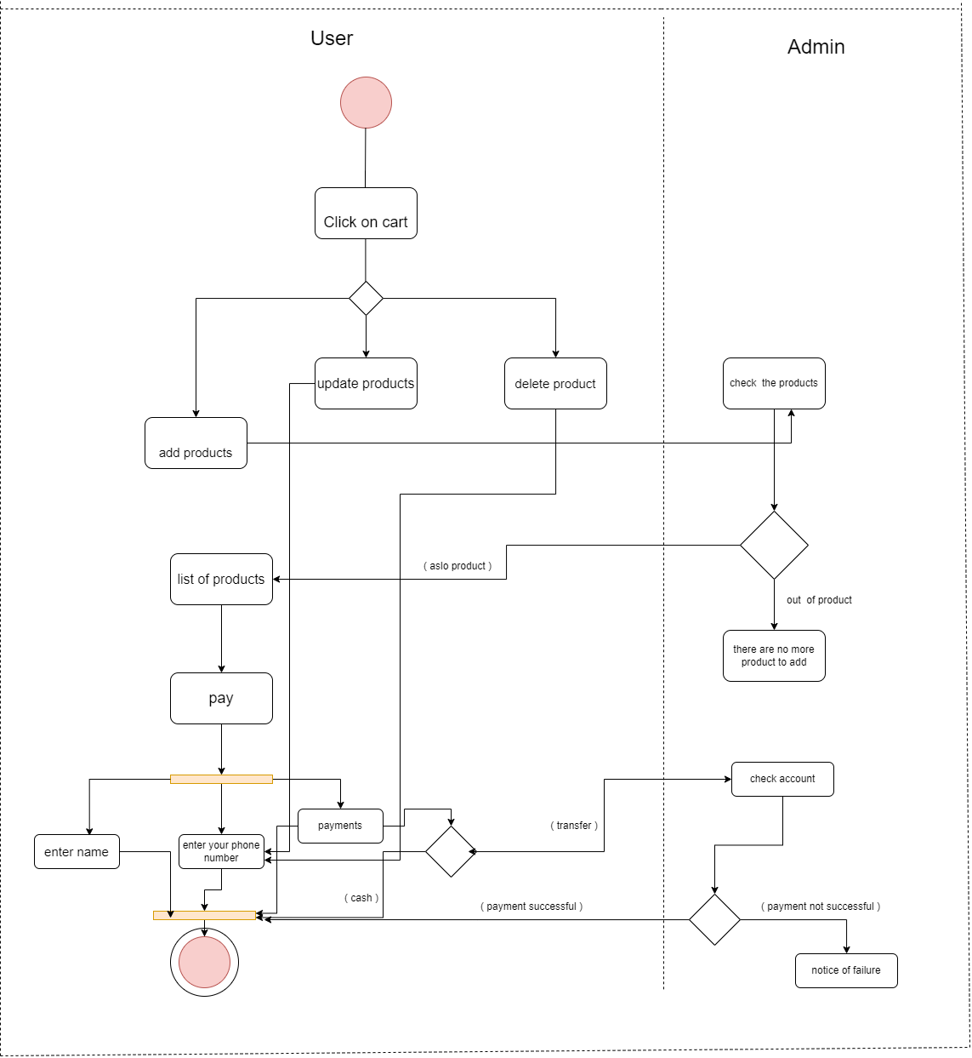

### Account Page

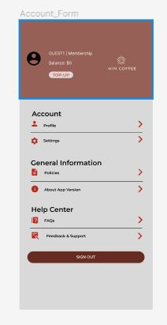

#### Screen Description

|  |  |  |  |  |  |  |
| --- | --- | --- | --- | --- | --- | --- |
| **No** | **Field Name** | **Control Type** | **Required** | **Data Type** | **Default Value** | **Description** |
| **1** | TOP-UP | Button | No | Button | Icon | TOP-UP show TOP-UP Page |
| **2** | Profile | Button | No | Button | Icon | Profile Button to view Information Account |
| **3** | Policies | Button | No | Button | Icon | Policies Button to show List of Policies |
| **4** | About App Version | Button | No | Button | Icon | Abou App Version to show Information About Application |
| **5** | FAQs | Button | No | Button | Icon | FAQs Button to show List of FAQs |
| **6** | Feeback & Support | Button | No | Button | Icon | Feeback & Support Button to show List of Feeback & Supports |
| **7** | Sign out | Button | No | Button | Text | Click to Sign Out Account |

#### WorkFlow

|  |  |  |
| --- | --- | --- |
| **Scenario** | **Actor** | **System** |
| **1. User click to TOP-UP Button** | 1.1 User click to TOP-UP Button | 1.2 Show TOP-UP Page |
| **2. User click to Profile Button** | 2.1 User click to Profile Button | 2.2 Show Profile Page |
| **3. User click to Policies Button** | 3.1 User click to Policies Button | 3.2 Show Policies Page |
| **4. User click to About App Version Button** | 4.1 User click to About App Version Button | 4.2 Show About App Version Page |
| **5. User click to FAQs Button** | 5.1 User click to FAQs Button | 5.2 Show FAQs Page |
| **6. User click to Feeback Button** | 6.1 User click to Feeback Button | 6.2 Show Feeback Page |
| **7. User click to Sign Out Button** | 7.1 User click to Sign Out Button | 7.2 Logout Account |

### Notify Page

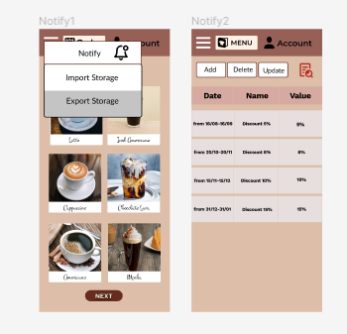

Notify Button

Menu App

#### Screen Description

|  |  |  |  |  |  |  |
| --- | --- | --- | --- | --- | --- | --- |
| **No** | **Field name** | **Control type** | **Required** | **Data type** | **Default value** | **Description** |
| **1** | Menu Bar | Button | Yes | Click | Text | Show feature on menu list |
| **2** | Notify | Button | Yes | Click | Text | Click to view Discount |
| **3** | Phiếu nhập kho | Button | Yes | Click | Text | Click to access Import Storage |
| **4** | Phiếu xuát kho | Button | Yes | Click | Text | Click to acces Export Storage |

#### WorkFlow

|  |  |  |
| --- | --- | --- |
| **Scenario** | **Actor** | **System** |
| **1. User click to notify button in Menu App** | 1.1 User click to notify button in Menu App | 1.2 Show list discount present at store |
| 1.3 User can view Discount(date, nameDiscount, value) | |

### Store Page

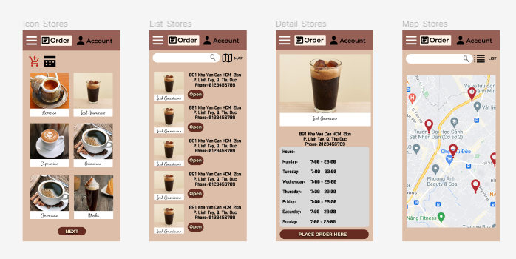

#### Screen Description

|  |  |  |  |  |  |  |
| --- | --- | --- | --- | --- | --- | --- |
| **No** | **Field name** | **Control type** | **Required** | **Data type** | **Default value** | **Description** |
| **1** | Icon Store | Control | Yes | Click | Image | Click to view store list location |
| **2** | Open | Button | Yes | Click | Text | Click to show detail store location |
| **3** | Map | Button | Yes | Click | Image | Click view map store |
| **4** | Search bar | Text bar | Yes | Click | Blank | Input store name to search |
| **5** | Place order here | Button | Yes | Click | Text | Click to access menu item |

#### WorkFlow

|  |  |  |
| --- | --- | --- |
| **Scenario** | **Actor** | **System** |
| **1. User click icon store in menubar** | 1.1 User click icon store | 1.2 Show list store location |
| 1.3 User click in open button | 1.4 Show detail store location |
| 1.5 User click in search bar | 1.6 Search bar appear show pointer, user can input, list store location change, show store finded |
| 1.7 User click in icon map | 1.8 Show map location |
| 1.9 User click in place order here button | 1.10 Return home page |

## Admin/Managers

### Admin Main Page – Management Products (Châu Nhật Tài)

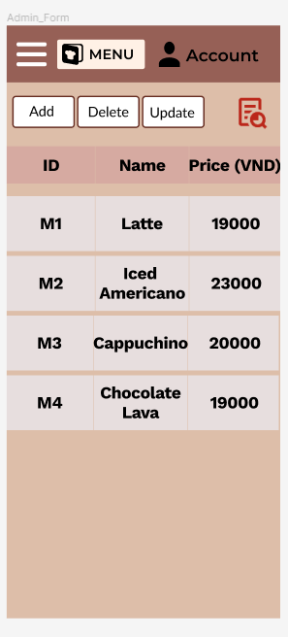

List Menu Item

Report Icon

Update Button

Delete Button

Add Button

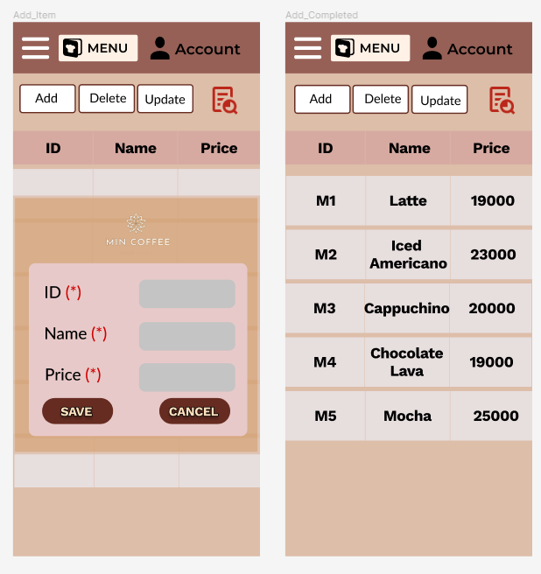

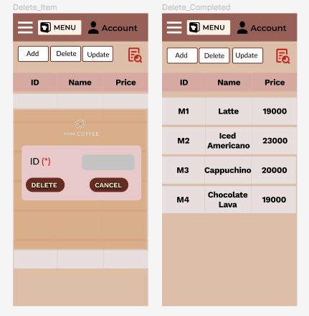

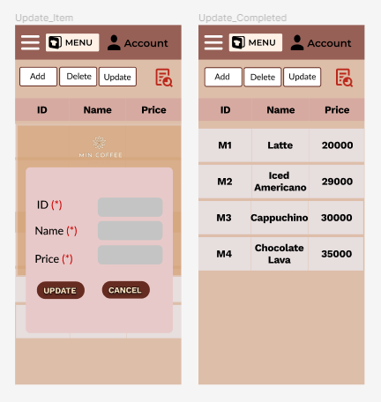

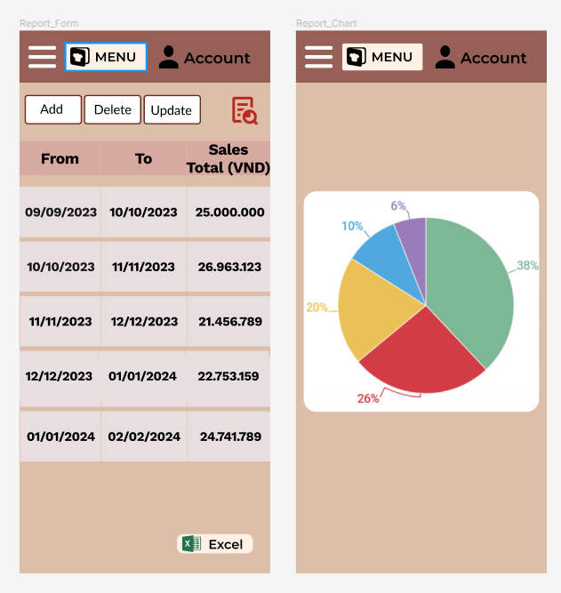

Excel Button

Report Icon

#### Screen Description

|  |  |  |  |  |  |  |
| --- | --- | --- | --- | --- | --- | --- |
| **No** | **Field Name** | **Control Type** | **Required** | **Data Type** | **Default Value** | **Description** |
| **1** | Add | Button | No | Button | Text | Add Button for Add Item in Menu List |
| **2** | Delete | Button | No | Button | Text | Delete Button for Delete Item in Menu List |
| **3** | Update | Button | No | Button | Text | Update Button for Update Item in Menu List |
| **4** | Report | Button | No | Button | Image | Icon Report Button show Report Page |
| **5** | Exel | Button | No | Button | Image | Icon Excel for Export Result to *.xlsx |

#### WorkFlow

##### Table Workflow

|  |  |  |
| --- | --- | --- |
| **Scenario** | **Actor** | **System** |
| **1. Admin click to Add Button** | 1.1 Admin click to Add Button | 1.2 Show Text Field for input information of Item |
| 1.3 Admin input information of Item | 1.4 If click “Save” Button, Item will add in Menu Item, Else return Admin Main Page |
| **2. Admin click to Delete Button** | 2.1 Adminclick to Delete Button | 2.2 Show Text Field for input information of Item |
| 2.3 Admin input id of Item | 2.4 If click “Delete” Button, Item will delete in by ID Menu Item, Else return Admin Main Page |
| **3. Admin click to Update Button** | 3.1 User click to Update Button | 3.2 Show Text Field for input information of Item |
| 3.3 Admin input information of Item | 3.4 If click “Update” Button, Item will update information by ID in Menu Item, Else return Admin Main Page |
| **4. Admin click to Report Icon** | 4.1 Admin click to Report Icon | 4.2 Show Report Page |

##### Activity

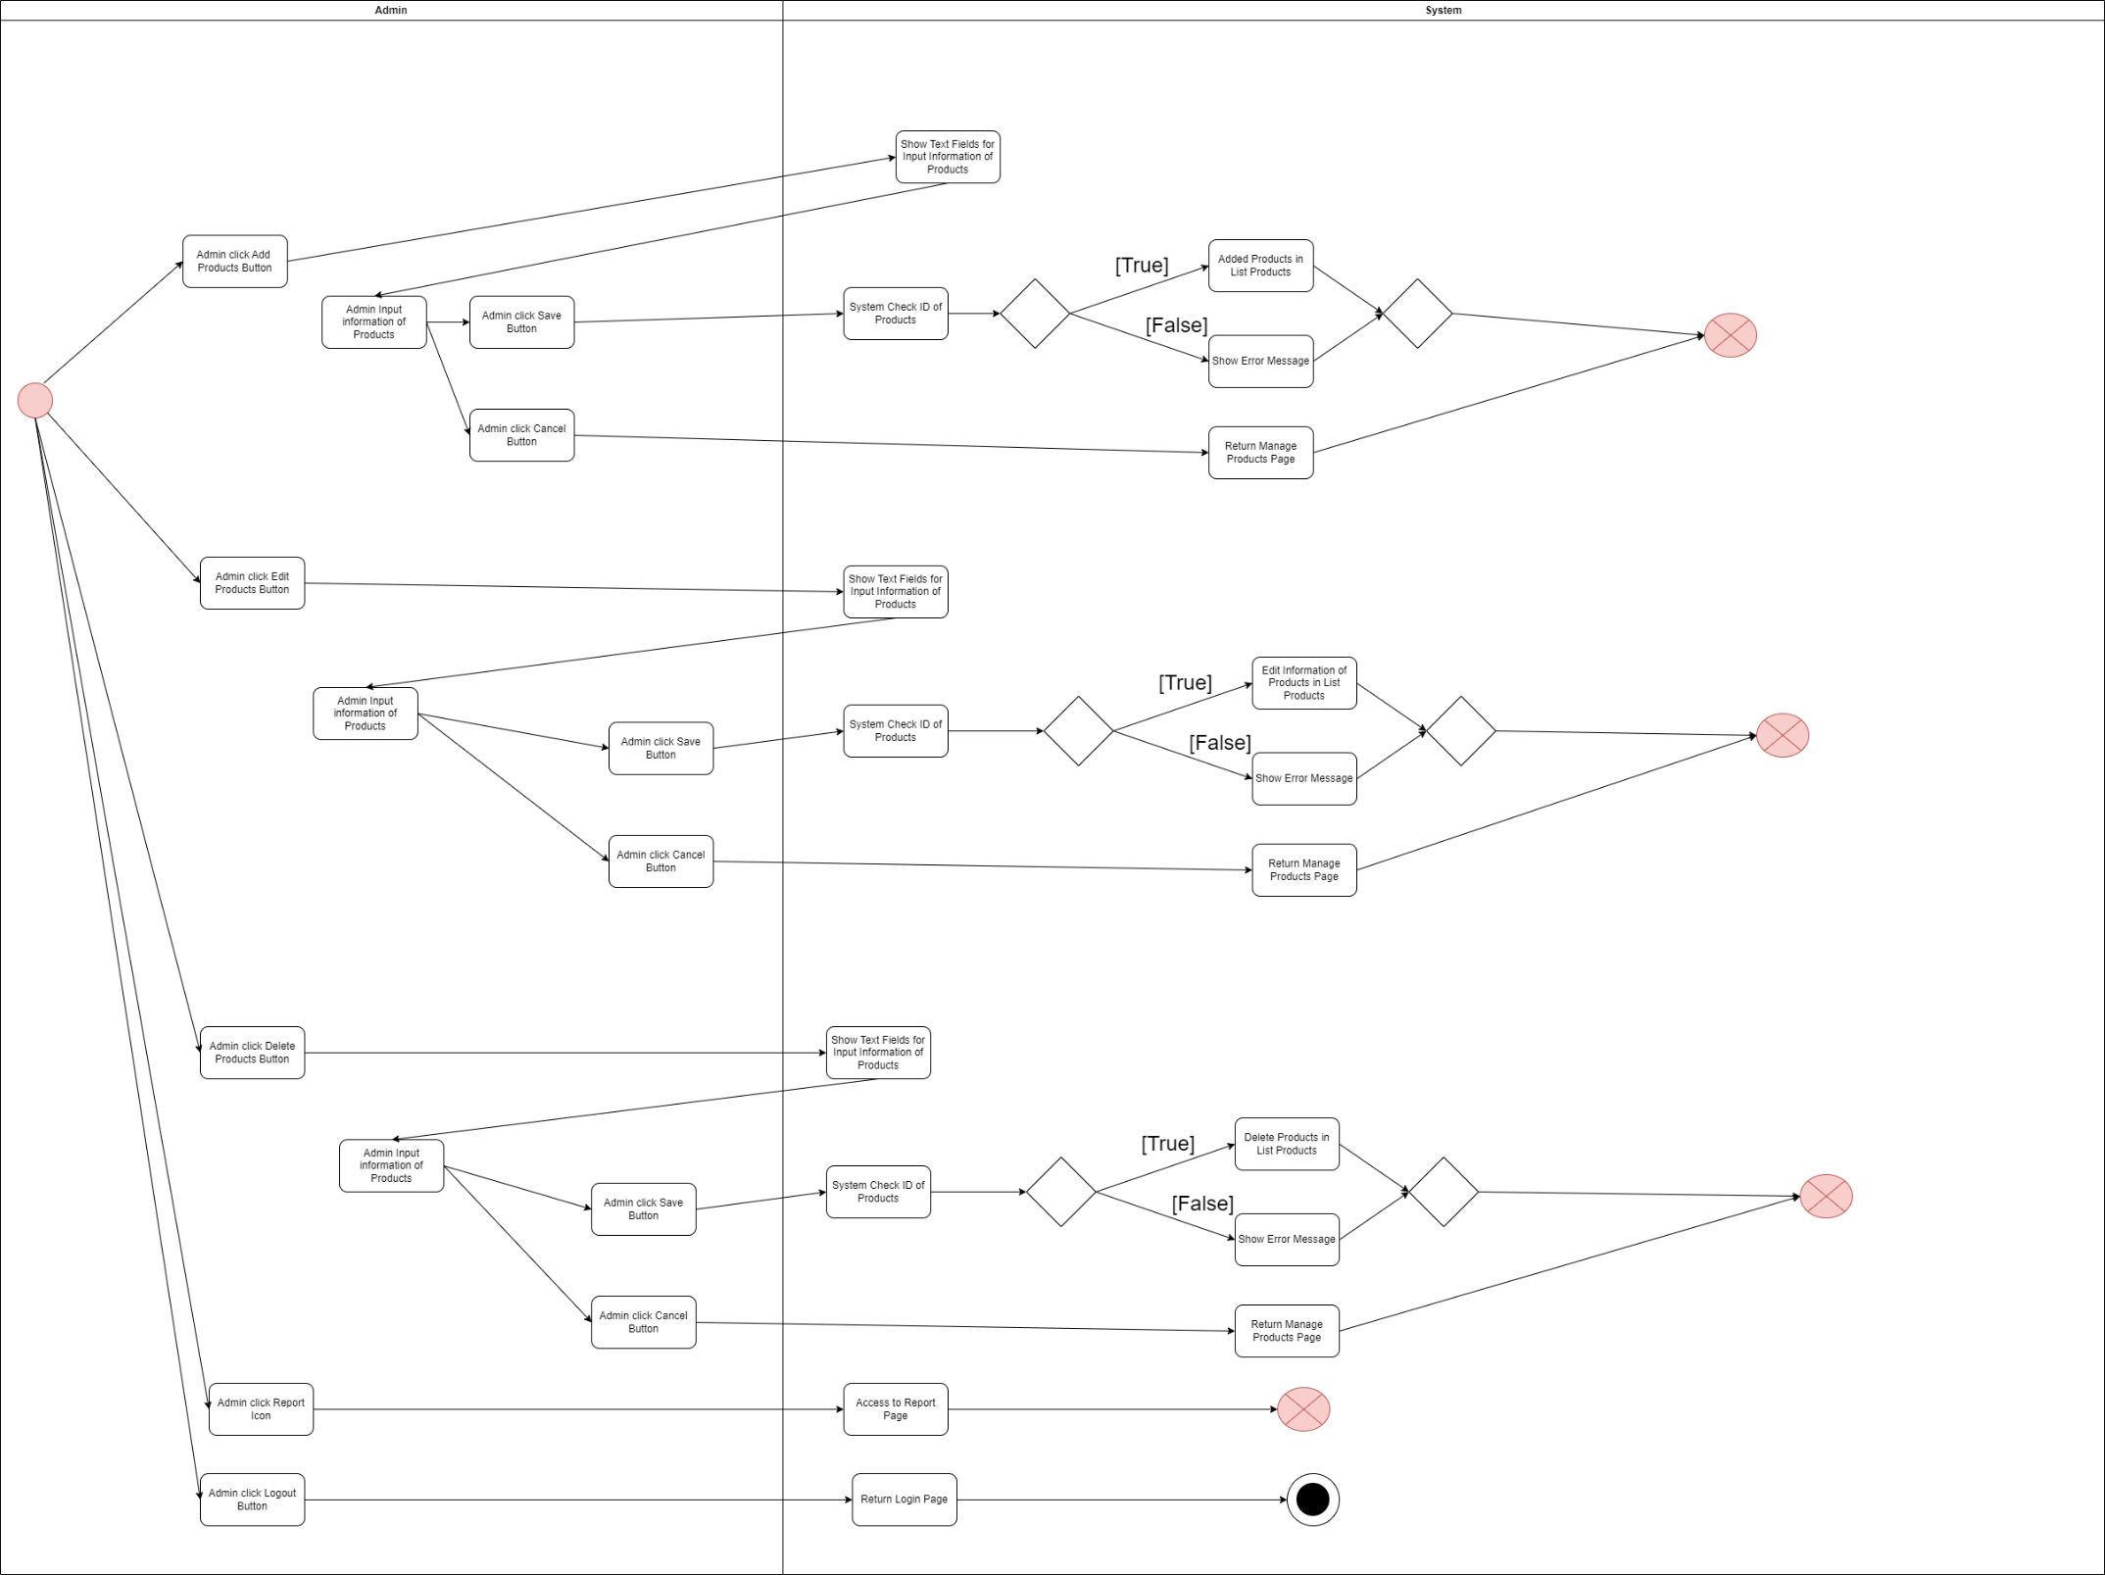

###### Add Activity

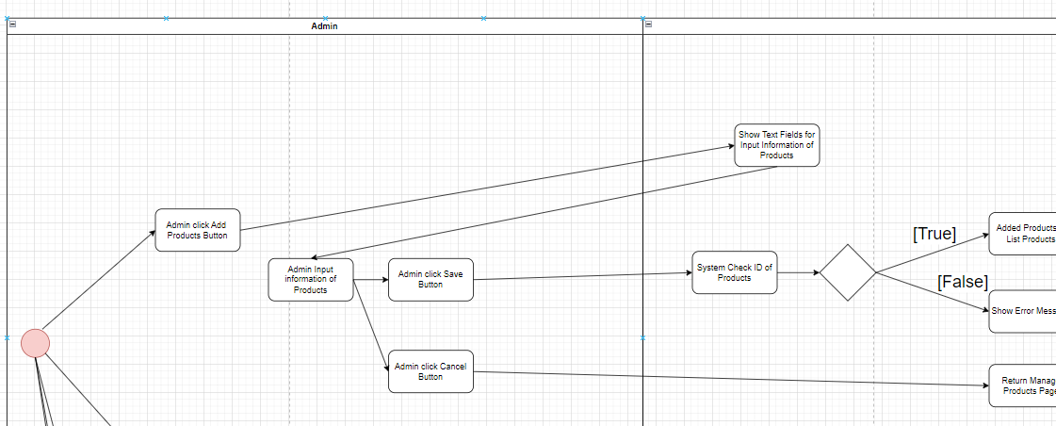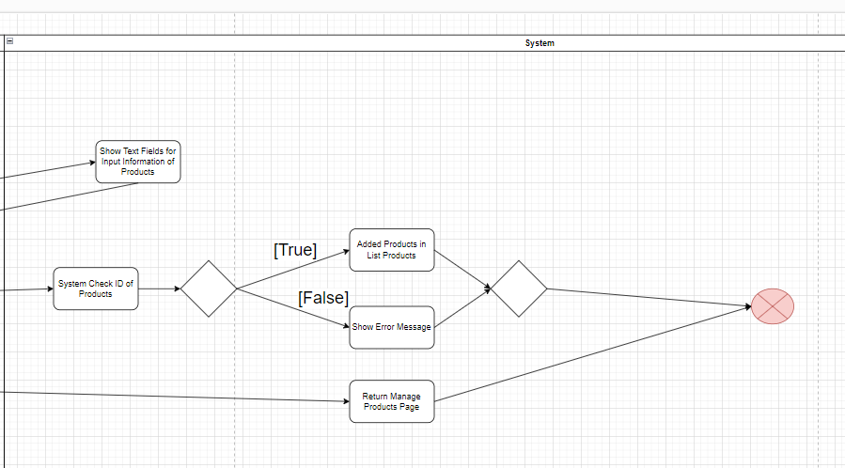

###### Edit Activity

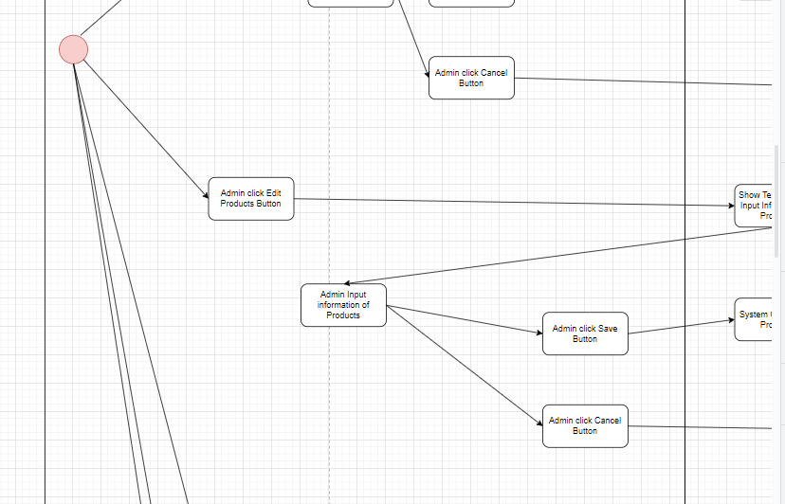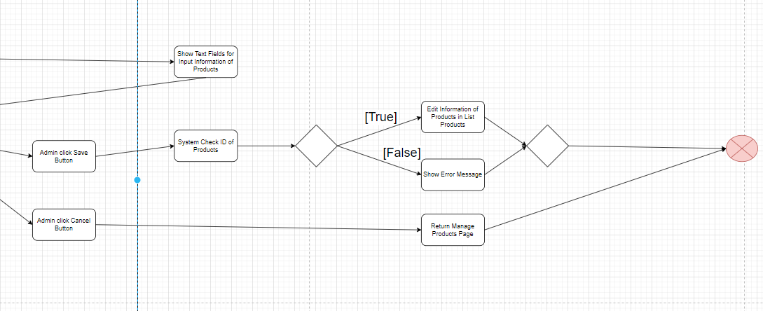

###### Delete Activity

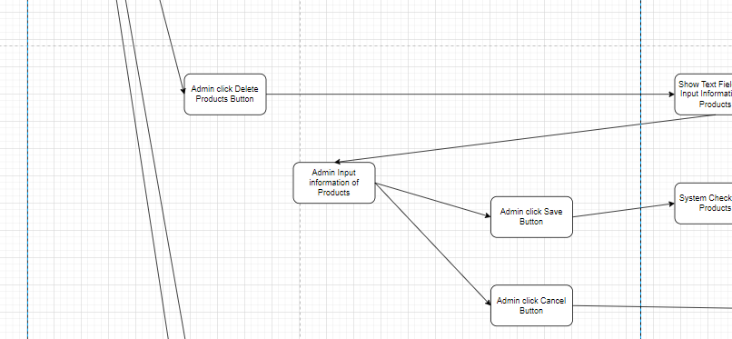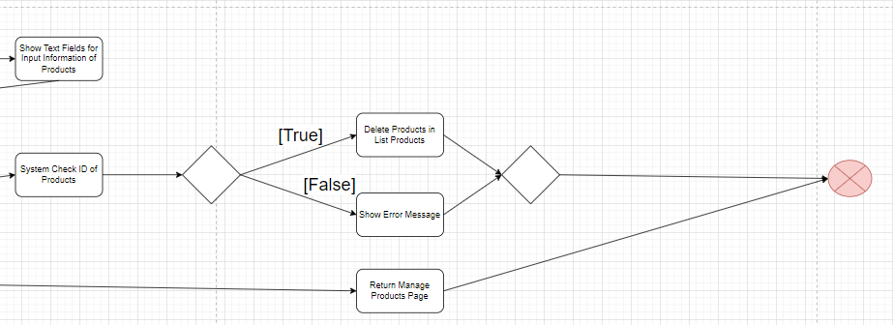

###### Report Activity



###### Logout Activity



### Import Store – Management Store (Nguyễn Đức Sáng)

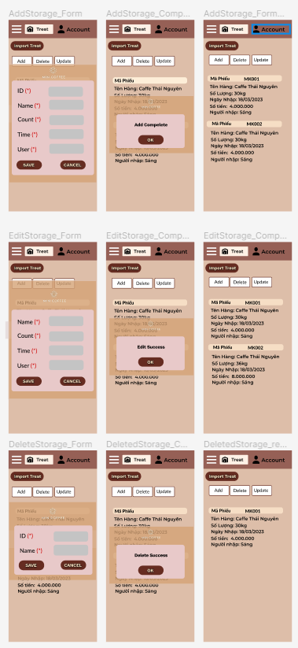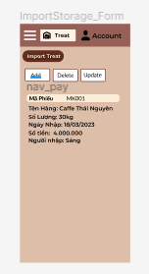

#### Screen Description

|  |  |  |  |  |  |  |
| --- | --- | --- | --- | --- | --- | --- |
| **No** | **Field name** | **Control type** | **Required** | **Data type** | **Default value** | **Description** |
| **1** | Save | Button | Yes | Click | Text | Show text field for user input |
| **2** | Delete | Button | Yes | Click | Text | Show text field for user input |
| **3** | Update | Button | Yes | Click | Text | Show text field for user input |
| **4** | Cancel | Button | Yes | Click | Text | Click to back Import Storage |

#### WorkFlow

##### Table Workflow

|  |  |  |
| --- | --- | --- |
| **Scenario** | **Actor** | **System** |
| **1. User click to import strorage in menubar** | 1.1 User click to import strorage in menubar | 1.2 Show import strorage |
| 1.3 User click in add button | 1.4 Show group text filed |
| 1.5 User click save button | 1.6 Save information user input and add item in strorage |
| 1.7 User click in delete button | 1.8 Show group text filed |
| 1.9 User click delete button | 1.10 Show warning: if user click “ok” delete in storage, else cancel action |
| 1.11 User click in update button | 1.12 Show group text filed |
| 1.13 User click update button | 1.14 Update item in strorage |

##### Activity

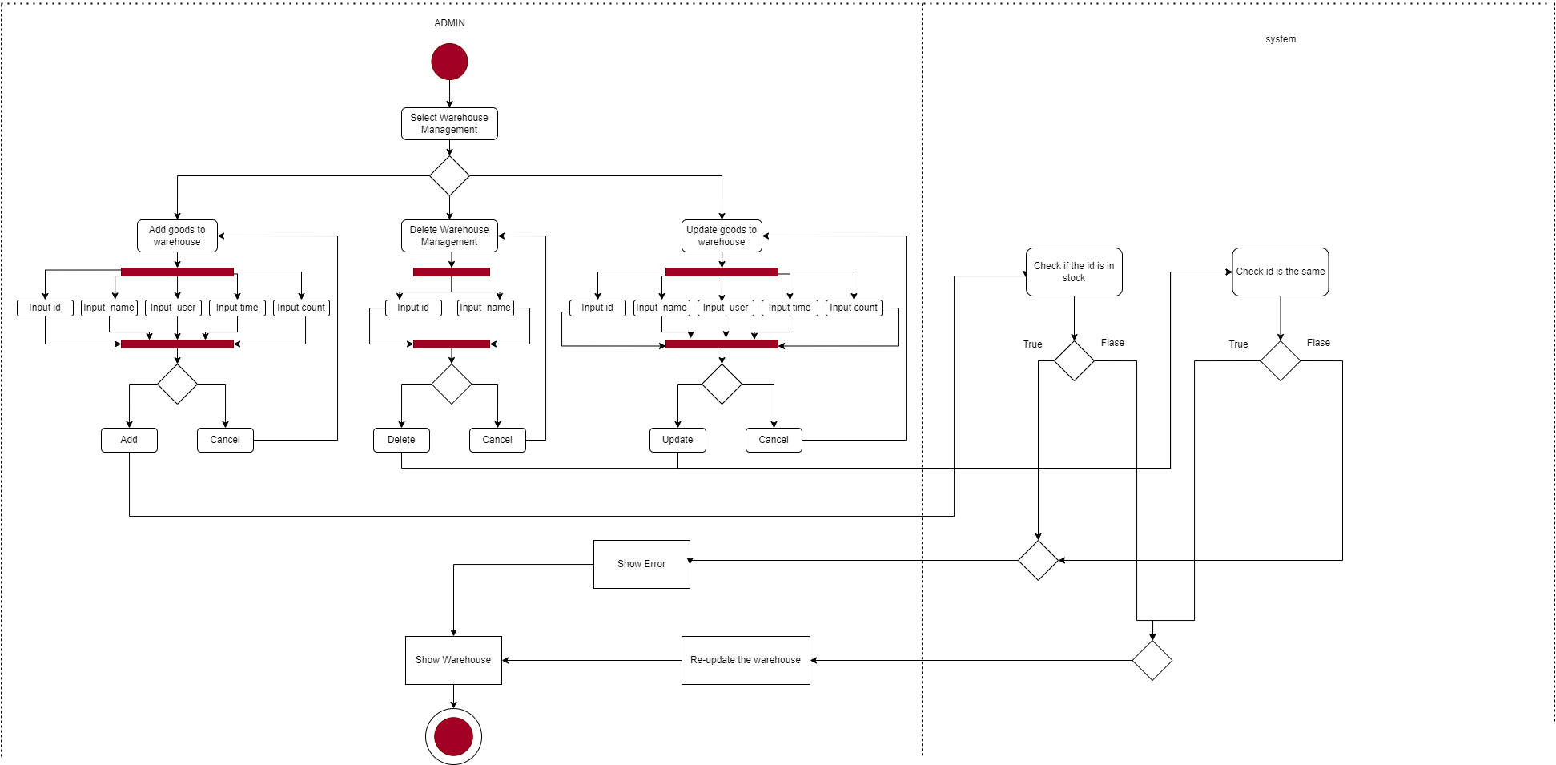

# Non-Functional Requirements

## Enviroment

- The program operates in a mobile phone environment with a stable connection. You only need a smart device like a phone with an internet connection to use our program.

- For phones using the Android operating system: minimum Android version 3.0 or higher.

- For phones using the iPhone operating system: minimum version IOS 7.0 or higher.

- For phones using the Windows Phone operating system: minimum version of Windows Phone 8.1 or higher.

- For phones using the Black Berry OS operating system: at least Black Berry OS version 10.0 or higher.

- When the user runs the program, the program will operate until the user exits the program. If the user just minimizes the program, it will automatically save the working process and enter standby mode. Standby mode will exist until the user exits the program completely.

## Capacity

- The program can store medium files, from 5gb-30gb

- Mainly program data is saved in parallel with the database. Just access the database and the program works well.

## Multitasking

- The program can open multiple tabs, up to 5 tabs when users need to enter a lot of data at the same time.

- Every time a user moves from one tab to another, it takes 0.5 seconds. When using 5 tabs at the same time, there will be a delay of about 2 seconds.

## Performance

- The time allowed to send search results is 5seconds

- The time allowed to fully display the app's menu information page is 15 seconds

- The time allowed for the system to respond to information received and processed from the user is 10 seconds

- Limit the number of people accessing the app to 1000 users

- Available system resources should be about 30%-40%

- Make sure the system operates normally when many people access and operate on it at the same time

## Safe

- The system automatically shuts down after 5 login attempts with incorrect account/password

- Safety compliance according to the world's common CC criteria (ISO/IEC 15408).

- If the app crashes, the system administrator is responsible for recovering and fixing it in the shortest possible time

## Security

- Prevent ads from appearing on the app

- Data must be absolutely accurate

- Send email notification to the account owner's phone if the wrong password is entered 5 times

- When a user changes a new password, the new password must not be the same as the previous old password

## Low battery consumption

- The software can run continuously for 4 hours using only 500 mAh, so phones with modest battery capacities of only about 2000 mAh can operate for more than 12 hours continuously without charging.

## Software installs on all types of devices

- The software can be installed on older devices such as Samsung j2, Samsung j7 or iPhone lines that have been around for a long time like iPhone 3 and 4.

## Stable level of software performance

- The software can operate normally without delay when switching tabs with a stable tab switching speed of only 0.05s on all older chips such as Snapdragon 600 of the Samsung Galaxy S5 series, Exynos 7420 of the Samsung Galaxy Note 5 series, A4 of iphone4 and A6 of iphone5.

## Availability requirements:

- Ensure the system is always ready to operate continuously, avoiding sales risks: power outages, system updates and upgrades.

## Quality characteristics of the software:

- The interface is researched for all ages, the software is easy to use. Is a solution for financial risks, miscalculation, cash deficit, invoice issuance, minimizing time for management, notification, and invoice payment.

## Restaurant location nearby

- When the user is near the location of the cafe, the notification bar will automatically display a notification suggesting a cafe

## Automatically congratulate user on their birthday

- When the user's birthday arrives, the app will automatically display a congratulatory message at exactly 00:00 on the customer's birthday.

## Automatically suggest dishes

- The system will suggest dishes on the notification bar based on the dishes the user often orders

## Ability to develop additional functions:

- When a user wants to develop a new function, the user can send a request to the conpany for development

## System data security

- When a situation occurs, such as a power outage or network outage... the data will be automatically saved and the next time the user logs back in, they can use the saved data.

## Default binding in functions

- The software's functions are clearly linked together, for example: the bank payment function will be linked to the shop owner's bank account

## Performance and Scalability

- Optimize system performance to handle high user traffic and complex operations.

- Ensure fast response times and low latency for an efficient user experience.

- Scale the system to accommodate increasing user demands without impacting performance.

## User Interface

- Create an intuitive and user-friendly interface for seamless interaction.

- Design visually appealing elements and clear navigation for enhanced usability.

- Allow customization options to cater to individual user preferences.

## Reliability and Availability

- Ensure the system is stable and available for users at all times.

- Implement backup and recovery mechanisms to prevent data loss.

- Monitor system performance to proactively address any issues or failures.

## Organizational requirements

- Promote effective teamwork and cooperation among employees to support the successful implementation and maintenance of the verification software.

## External requirements

### User feedback mechanism:

- Establish a mechanism to collect feedback from users, partners or customers to continuously improve the verification system based on input from external stakeholders.

### Legal requirements:

- Identify legal regulations related to the user's industry. Check to see if there are norms, standards, or laws that need to be followed.

# Use-Case Diagram

*Show Use-Case diagram image in this section*

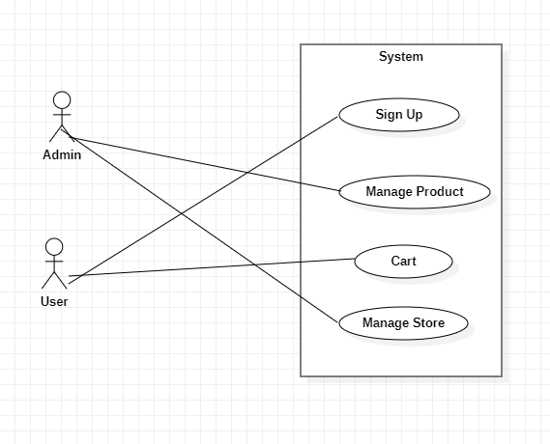

## Actors

|  |  |
| --- | --- |
| **ID** | **Actor name** |
| **1** | Admin |
| **2** | User |
| **3** | Database |

## Use-Cases

|  |  |
| --- | --- |
| **ID** | **Use-Case name** |
| **01** | Sign Up |
| **02** | Manage Products |
| **03** | Cart |
| **04** | Manage Stores |

## Use-Case Manage Products

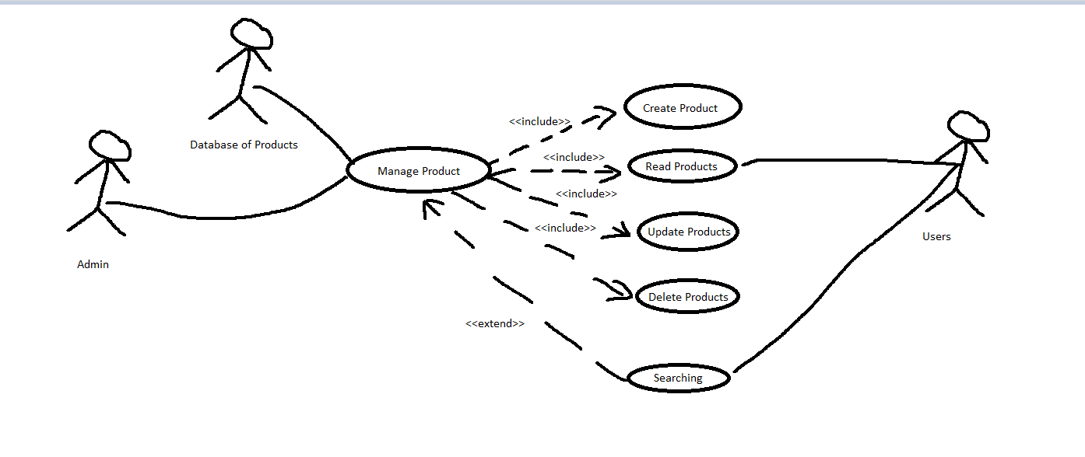

### Use-Case ID: 02

### Use-Case Owner Name: Châu Nhật Tài

### Brief Description

Actor: Admin

Use-Case product management will allow admins to add, delete, and edit products in the store menu. For regular users, they only have the right to view the product list.

Actor: Users

For users, they can only view the product list and select the product, displaying product details for the user to add to the cart.

### Flow of Events

#### Basic Flow

Admin logs into Use-Case product management, exercises the rights to add, delete, and edit products from the add, delete, and edit product buttons. When you press the button, a confirmation dialog box will appear, press ok to confirm, the program will automatically update the product list.

#### Alternative Flows

If the confirmation dialog box appears, the admin selects cancel to return to the product list. All product information remains unchanged.

### Special Requirements

The product list must have data, the data is retrieved from the database. Users or Admins need to log in to use Use-Case Manage Product

### Pre-Conditions

#### Admin and Users are authenticated

#### There must be product data in the database

### Post-Conditions

#### Document contains only valid SGML tags.

#### Information of product in database has been updated with new value.

### Extension Points

In Use-Case Manage Product, additional functions can be expanded:

#### Search - find products by product code, find products by product type.

#### Printing: print the list of products available on the menu.

## Use-Case Sign Up

### Use-Case ID: 01

### Use-Case Owner Name: Phạm Thế Minh

### Brief Description

Provide each person with an account to become a member of Min Coffee, used to order items on the restaurant's menu. You can register by phone number, facebook, google, twitter.

### Flow of Events

#### Basic Flow

The user clicks on the registration section. The application will then take the user to the registration page to enter their account, password, and phone number to register. After entering, the user clicks register to notify the user of success and return the user to the login screen

#### Alternative Flows

When the user has entered the account, password, and phone number but intends to no longer register, the user will press the cancel button, then all the information the user has just entered will no longer be available and the message "You Do you want to cancel this operation? If not, the user will continue to enter registration information. If so, all user information will be canceled and the user will return to the login page.

When the user clicks to register an account, the system will check to see if that account already exists or is the same as an already registered account. If the account already exists or is duplicated, the system will not be able to register the account. account and send a notification to the user that "Account already exists". Then let the user re-enter

### Special Requirements

#### You can choose to hide your password when registering

#### There is a login button so that after registering, you will be logged in to the app's home page

### Pre-Conditions

#### The user's identity has been authenticated.

#### The user's computer has enough free memory to launch the task.

#### Registration information cannot be left blank

#### 1 phone number can only register 1 account

### Post-Conditions

#### 1 user will have 1 account to be able to use the Min coffee app

### Extension Points

#### You can quickly register with your Google, Facebook, Twitter account

## Use-Case Manage Stores

### Use-Case ID: 04

### Use-Case Owner Name: Nguyễn Đức Sáng

### Brief Description

UC04.1 Admin goes to the warehouse management page to perform CRUD functions and search for products in the warehouse.

UC04.2 Users go to the warehouse management page to view products and search for products in the warehouse

### Flow of Events

#### Basic Flow

UC04.1 Admin adds new products to the warehouse.

UC04.2 Admin deletes products into inventory

UC04.3 Admin update products into inventory

UC04.4 Admin views products in stock

UC04.5 Admin searches for products in the warehouse

UC04.6 User views products in stock

UC04.7 User searches for products in the warehouse

#### Alternative Flows

UC04.1 When pressing the add product button, a confirmation message appears. Pressing no will return to the add page and reset the edit text.

UC04.2 When pressing the deletes product button, a confirmation message appears. Pressing no will return to the deletes page and reset the edit text.

UC04.3 When pressing the update product button, a confirmation message appears. Pressing no will return to the update page and reset the edit text.

UC04.5 When The admin pressing the product search button, there will be additional search fields in addition to searching by product code, by product type, and by product name.

UC04.7 When The user pressing the product search button, there will be additional search fields in addition to searching by product code, by product type, and by product name.

### Special Requirements

#### You can choose to hide your password when registering

#### There is a login button so that after registering, you will be logged in to the app's home page

### Pre-Conditions

#### Must have an admin or user account

#### When an admin deletes a product, the product code must be included

#### When an admin edits a product, there must be a product code so the system can edit

#### When an admin edits a product, there must be a product code so the system can edit

### Post-Conditions

#### Document contains only valid SGML tags.

#### Information of stores in database has been updated with new value.

### Extension Points

#### The search section can search in many different ways for both admin and user

## Use-Case Cart

### Use-Case ID: 03

### Use-Case Owner Name: Võ Tú

### Brief Description

Admin  
- Admin can view, edit and delete products in the shopping cart, control users, and product statistics

User

-Users can add, delete, edit products, view order information in the shipping process, and purchase orders.

### Flow of Events

#### Basic Flow

UC03.1 Admin can list products in the shopping cart  
UC03.2 Admin can view products in the cart

UC03.3 Users can add products to the cart

UC03.4 User can delete products in cart

UC03.5 Users can increase or decrease the quantity in the shopping cart

UC03.6Users can pay for products in the shopping cart

#### Alternative Flows

UC03.1 When the user presses delete, the image will lose the product just deleted

UC03. 2 When the user presses milk, the screen shows whether the product has decreased or increased in quantity

UC03.3When the user fails to pay, the screen will return to the payment page

### Special Requirements

Identify any additional requirements, such as nonfunctional requirements, for the Use-Case that may need to be addressed during design or implementation. These may include performance requirements or other quality attributes.

### Pre-Condition

#### Must have an account

#### When pressing payment, there must be products in the cart

#### When purchasing a product, users need to fill in personal information

### Post-Conditions

Describe the state of the system at the conclusion of the Use-Case execution. Number each postcondition. Examples:

Document contains only valid SGML tags.

Information of cart in database has been updated with new value.

### Extension Points

Describe the state of the system at the conclusion of the Use-Case execution. Number each postcondition. Examples:

Document contains only valid SGML tags.

Information of cart in database has been updated with new value.

# Q & A List

**Họ Tên:** Châu Nhật Tài

**Mã Lớp HP:** 6001

**Môn:** Nhập môn Công Nghệ Phần Mềm

**Nội dung:** Đặt câu hỏi cho bài học chương 4

**Chấm điểm thành viên nhóm**

|  |  |  |  |
| --- | --- | --- | --- |
| **STT** | **Họ Tên** | **Nhận Xét** | **Thang Điểm 10** |
| **1** | Châu Nhật Tài (Nhóm Trưởng) | 20/20 | 10 |
| **2** | Nguyễn Đức Sáng | 20/20 | 10 |
| **3** | Phạm Thế Minh | 20/20 | 10 |
| **4** | Võ Tú | 20/10 | 10 |

**Bài Làm**

## 4.1 Page 4/70 REQUIREMENT?

- A service that the system must perform or a constraint that the system must satisfy. Am I understanding this correctly?

## 4.1 Page 5/70 REQUIREMENT ENGINEERING?

- Am I understand that the descriptions of services and system constraints in the technical requirements process are correct?

## 4.2 Page 9/70 USER REQUIREMENT?

- In your opinion, the requests from users are expressed in natural language, which can include a diagram of the services the system provides and constraints from the user, is it correct to write for the user?

- Users: Customer managers, customers, engineers, contract managers, system designers

## 4.2 Page 10/70 SYSTEM REQUIREMENT?

- Is a document that describes functions, services, and constraints in detail. Define and clarify the functions that can be performed. Is it part of the contract between the customer and the contractor?

## 4.2 Page 12/70 FUNCTIONAL REQUIREMENT?

- Are the service requirements that the system can meet, how the system reacts to particular input data and how the system should run those cases, Am I understand right?

## **4.2 Page 12/70 NON-FUNCTIONAL** REQUIREMENT?

- Are requirements for service or function constraints such as time constraints or constraints during the development process. Applies to the entire project, not just one function or requirement. Is that correct?

## 4.3 Page 14/70 FUNCTIONAL REQUIREMENT?

- The functions that users request can be simple or complex functions that the system must do such as adding, deleting, editing, or more advanced than statistics or printing something. Am I understanding this correctly?

- System functions include detailed descriptions of services and functions in the system. Am I understand that correctly?

## 4.3 Page 15/70 MENTCARE SYSTEM?

- Each system function will have its own meeting areas, each meeting area is divided into each day, with a waiting list. Users can search for meeting schedules for that day using the special employee ID issued by the system. Am I understanding this correctly?

## 4.3 Page 16/70 REQUIREMENT IMPRECISION?

- System requirements must be clear. Vague requirements will cause different interpretations between users and developers.

Eg:

User: Search all meeting schedules in the clinic

Developers: Search all meeting schedules in a clinic

Am I understanding this correctly?

## 4.4 Page 19/70 NON-FUNCTIONAL REQUIREMENT

- Non-functional requirements are requirements regarding time constraints, storage management, and reliability

- Bind I/O device capabilities, system representation

- Process requirements are also specified in terms of IDE, development language and programming method

- If non-functional requirements are not met, the system will become useless

- Am I understanding this correctly?

## **4.4 Page 21/70 NON-FUNCTIONAL** CLASSSIFICATION

- Non-functional requirements are divided into 3 main branches:

+ Product requirements

+ Organizational requirements

+ External requirements

- Am I understanding this correctly?

## **4.4 Page 22/70 NON-FUNCTIONAL REQUIREMENT** IMPLEMENTDATION?

- Non-functional requirements can affect the entire system.

- So to ensure work performance is met, we must organize a system to minimize communication between components.

- Am I understand that correctly?

## **4.5 Page 28/70 REQUIREMENT ENGINEERING** PROCESS?

- The development processes used for RE are very broad based on the application domain, the people involved, and the development organization

- There are 4 common development processes:

+ Ask for suggestions

+ Requires analysis

+ Request confirmation

+ Management requirements

- Am I understanding this correctly?

## **4.5 Page 30/70 REQUIREMENT ELICITATION AND** ANALYSIS?

- Requirement Elicitation is also known as request for suggestion

- Technical members work with customers to find/clarify the application domain, the services the system should provide and the constraints.

- Can include end users, managers, engineers involved in maintenance, etc. They are called Stakeholders (stakeholders)

- Am I understanding this correctly?

## 4.5 Page 31/70 REQUIREMENT ELICITATION?

- Software engineers must work with a system of stakeholders to clarify requirements:

- Includes steps:

+ Detect requirements

+ Classification and organization

+ Prioritize and negotiate requirements

+ Requirements specification

- Am I understanding this correctly?

## **4.5 Page 32/70 PROBLEM OF REQUIREMENT** ELICITATION?

+ Stakeholders are not clear what they really want

+ Stakeholders describe requirements in their own words

+ Different stakeholders will conflict about requirements

+ Organizational and political factors can affect system requirements

+ Requirements change throughout the analysis process. New stakeholders may emerge and environments emerge

- Am I understanding this correctly?

## 4.5 Page 35/70 REQUIREMENT DISCOVERY?

- The process of obtaining information about system requirements and distilling user and system requirements from that information

- Interaction is with system stakeholders from management and external stakeholders

- A normal system will have many stakeholders

- Am I understanding this correctly?

## 4.5 Page 36/70 SYSTEM STAKEHOLDERS?

- People or organizations that influence or are related to the system are called StakeHolders

- Types of StakeHolder:

+ End users

+ System management

+ System owner

+ External stakeholders

- Am I understanding this correctly?

## 4.6 Page 41/70 INTERVIEWING?

- Formal and informal interviews with stakeholders are part of most RE processes

- Types of interviews:

+ Closed interview: based on pre-prepared questions

+ Open interviews: where issues are explored with stakeholders

- Effective interviews:

+ Be open, avoid preconceptions about requirements and be willing to listen to stakeholders

+ Prompt interviewees to discuss using a questionnaire to propose requirements, or work together on a prototype system.

- Am I understanding this correctly?

## 4.6 Page 42/70 INTERVIEW IN PRACTICE?

- Usually a combination of closed burns and open burns

- Interviews are useful for gaining an overall understanding of what stakeholders do and how they might interact with the system.

- The interviewer should be open-minded without preconceived ideas about what the system should do.

- Need to remind users to talk about the system by suggesting requirements instead of just asking what they want

- Am I understanding this correctly?